**DREAM HOUSE REALTY**

*Introduction:*

*1,) Purpose*

*The Zoho book are mainly used for the purpose of recording the purchase and sale in the real estate business. And it also used to record the accounting transaction to record, analysis, summaries and then gives as a financial reports to make further decision in the business*

*2,)* **Overview**

*Dream Homes Realty, a construction company, uses Zoho book to track project expenses , Manage subcontractor payments, and handle invoicing. They can generate estimates and invoices for clients, track job costing, and monitor the profitability of each project. Zoho book provides them with financial insights to make informed decisions*

**2) PROBLEM DEFINITION AND DESIGN THINKING**

**2.1)EMPATHY MAP**

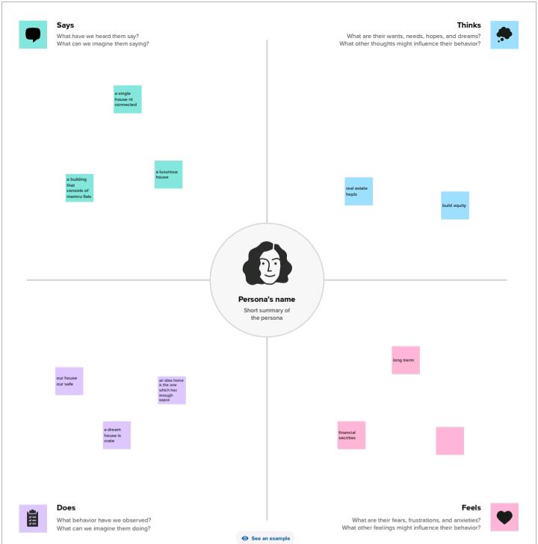

**2.2) IDEATION AND BRAINSTORMING MAP**

**3) Result:**

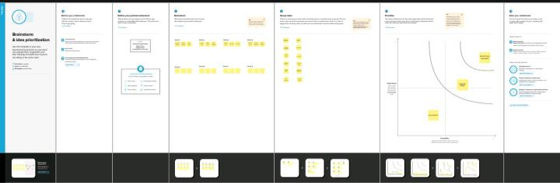 **3.1)PROFIT AND LOSS A/C**

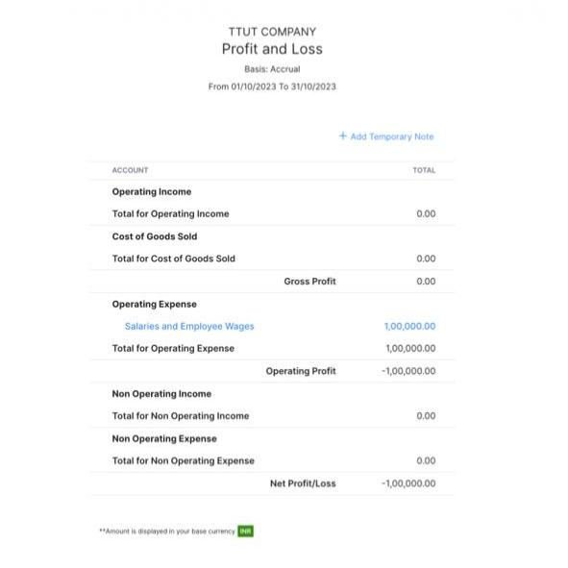

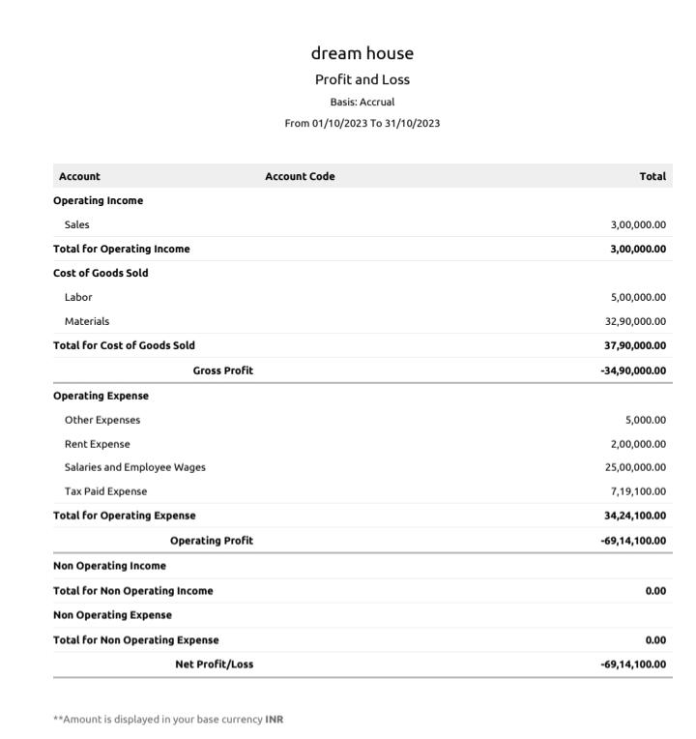

**3.2) BALANCE SHEET**

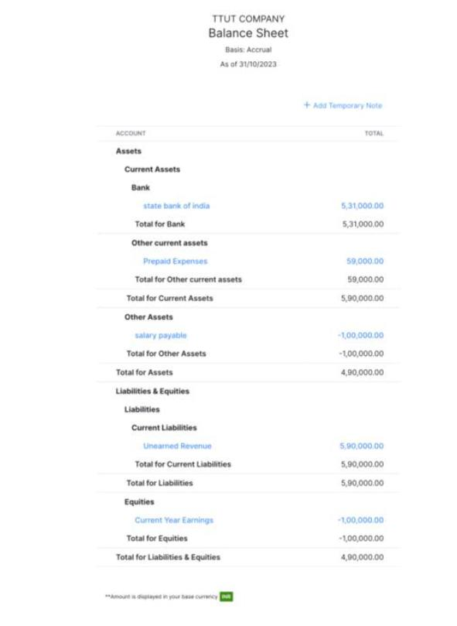

**4)ADVANTAGES AND DISADVANTAGES:**

**Advantages:**

1. *Invoicing and Billing*
2. *Expense tracking*
3. *Minimize Data Lost*
4. *Report Generation*
5. *Inventory management*

**Disadvantages:**

1. *Difficult to modify invoice*
2. *Maximum of 10 users*
3. *Time tracking must be tied to project*
4. *Limited Bank syncing*
5. *Difficult to modify Bills*

**5) APPLICATION**

**The Zoho book are used to prepare the accounts for the business and also to prepare the bill and invoice for the business. This cloud based accounting software is very in the business. In dream house Realty users the Zoho book to track the project expenses, Manage sub contractor payment and handle invoicing. They can generate estimates and invoices for clients, track job costing, and monitor the profitability of each project**

**6) CONCLUSION:**

*The Zoho book are useful to maintain, record, summaries and analysisy accounting entries made in this cloud based software. We need any manual records to maintain the accounts. Then we can add the journal and then we can get the profit and loss A/C, Balance sheet, GST report and Etc. We can prepare the bill and maintain accounts. We can prepare the bill and maintain accounts in the software.*

**7) FUTURE SCOPE**

* *It maintain the accounts as well as the billing software in one software*
* *It provide the financial report to take future decision for the business*
* *It also help to reduce the work of the accountant to maintain accounts*
* *It gives less cost for maintain accounts*